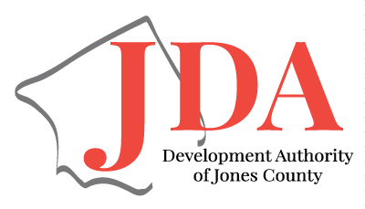
Development Authority of Jones County

Meeting Agenda
April 25, 2024
9:00 AM

Call to Order Greg Mullis

Consent Items:
- Approval of Agenda
- Approval of Minutes
- Financial Report Brian Utley

New Business:
- GEDA Spring Workshop (May 21-23) Haley Watson

Old Business:
- Bank Account Signers Brian Utley
- Marketing Comm./ Industrial Properties Haley Watson
- By-Laws Greg Mullis
- Preferred Projects for Jones County Greg Mullis

Directors Report Haley Watson
Executive Session (Economic Development)

Adjourn Greg Mullis

2023/2024 Plan of Action
Promotions | Visits/ Touches | Workforce  Development | Education | Government Affairs
Project Manager Gifts | State Project Manager Visits: (8/12) | Job Fair for Industries  (Canceled) | Carl Vinson Continuing Ed. Classes | Update County Quarterly  (1/4)
Project Manager Dinners (2/2) | GEDA follow up meetings | Educator Externship | CEDOP (Community Econ. Dev. Org. Program)
 |  | MGEA Monthly Meetings
 |  | JCCCA 9th Grade Pathway Event (3/25-26/24)
 |  | Career Vehicle Day/ Be Pro Be Proud (2/2)

